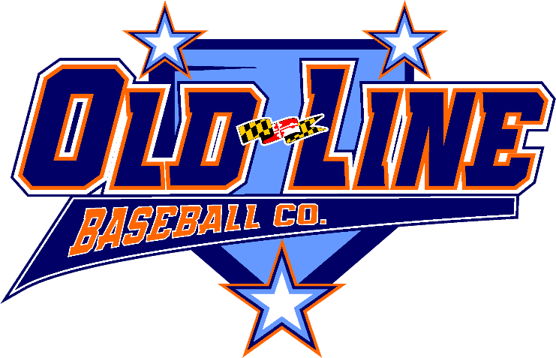

Old Line Baseball Company

OFFICIAL TEAM ROSTER
&
WAIVER & RELEASE OF LIABILITY

****PLEASE READ BEFORE SIGNING ON THE OTHER SIDE OF THIS DOCUMENT****
In consideration of being allowed to participate in a Old Line Baseball Company tournament, related events and activities, each of the undersigned parents or guardians acknowledges and agrees that:

- The risk of injury from the activities relating to the tournament is significant, including the potential for permanent paralysis and death, and while rules, equipment and personal discipline may reduce the risk, the risk of serious injury does exist;
- I knowingly and freely assume all such risks, both known and unknown, even if arising from the negligence of the released parties or others, and assume full responsibility for participation by my child in this event;
- I willingly agree to comply with the stated and customary terms and conditions for participation; however, if I observe any unusual significant hazard during the event, I will bring such hazard to the attention of the nearest tournament official immediately;
- I, for myself, my child and on behalf of my and my child’s heirs, assigns, personal representatives and next of kin, hereby release, hold harmless and agree to defend Old Line Baseball Company, LLC its officers, directors, employees, agents and representatives, as well as other participants in the event (the “Released Parties”), from and against any loss, liability, claim, damage or expense arising out of my child’s participation in the event, including any and all injury, disability, death or loss or damage to person or property, whether arising from the negligence of the Released Parties or otherwise; and
- I have read this Waiver and Release of Liability, fully understand its terms, understand that I have given up substantial rights by signing it, and sign it freely and voluntarily without any inducement.

I hereby approve of my child’s participation in the Old Line Baseball Company tournament, related events and activities. I further certify that he or she is in good health and able to participate without restriction in the event. I authorize any tournament official or a representative of Old Line Baseball Company to act for me according to his or her best judgment in the event of any emergency requiring medical attention involving my child.

Old Line Baseball Company

Signature Page for OFFICIAL TEAM ROSTER
& Waiver and Release of Liability

**PLEASE READ Page 1 OF THIS DOCUMENT BEFORE SIGNING BELOW**

By signing below, each parent or guardian:
- Confirms that he or she has read the Waiver and Release of Liability on the other side of this page
- Acknowledges and agrees to the terms of the Waiver and Release of Liability; and
- Verifies that the date of birth of his or her child set forth below is correct.

Player Name | DOB | Jersey # | Parent/Guardian Name | Parent/Guardian Signature

Team Manager’s Affidavit

The undersigned, manager of the team listed below, hereby states that all of the information supplied above is correct, to the best of the undersigned’s knowledge, and that all of the parents or guardians signed their signatures in their own handwriting.

Manager’s Name (print): ________________________

Manager’s Signature: ______________________ Date:________________

Team Name: ________________________

Division: CP 8UM 8U 9U 10U 11U 12U 13U 14U

